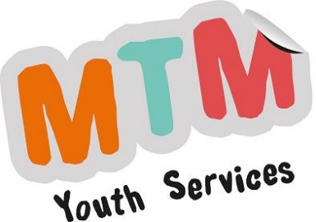

MTM Youth Services CIC
Online Youth Work Offer
Live streaming is a valuable way that MTM Youth Services Youth Workers can connect with young people online. We will offer young people access using a service called Zoom (www.zoom.us) and their own devices and webcams. MTM Youth Workers will be experienced in Zoom and will understand the privacy and mute settings.
A minimum of two MTM Youth Workers will lead every online session, with an appropriate maximum number of young people invited and taking part. Only young people who have been given consent will be allowed to join the session.
We will talk to young people about online safety before the session starts. We will make sure they understand that live streaming is live and that any comments they make will be seen and heard by others.
We will remind them not to share any personal information and not to respond to contact requests from people they don’t know. We will also ask young people to be aware of their environment (where they are broadcasting from) and being respectful to other people in their household at the time of the session
We will make sure they know who to tell if they see or hear anything upsetting or inappropriate.
MTM will not reproduce or distribute the video chat.
If young people tell us something that makes us very worried for their safety during the group chat, or that they may be in danger, then we will chat to them in a private session about whether other people need to know. In exceptional circumstances we might need to break this confidentiality if we believe that the young or another young person is in immediate danger.
What we expect from Young People during an online session
- Treating each other with respect
- Respecting confidentiality
- Welcoming and including new people to the online session
- Being understanding of each other’s differences, and not making assumptions about anyone’s gender identity or sexual orientation
- Not swearing or using violent, bullying or abusive behaviour/language, nor innuendos
- Not using screen capture during the session or any other method of recording
- To respect each other’s personal space and boundaries.
- To not using drugs and/or alcohol before or during sessions.
Reviewed by the Directors 27th March 2020

